🔌RFID Pinout and NodeMCU Connection Table
RFID Pin | Connects To (NodeMCU Pin) | Description
VCC | 3V3 | Power
GND | GND | Ground
RST | D3 | Reset pin
SDA (SS) | D8 | Chip Select
MOSI | D7 | SPI Data to RFID
MISO | D6 | SPI Data from RFID
SCK | D5 | SPI Clock

🖥️ I2C LCD Pinout and NodeMCU Connection Table

LCD Pin | Connects To (NodeMCU Pin) | Description
VCC | 5V | Power (The LCD module typically needs 5V)
GND | GND | Ground
SDA | D2 | Serial Data (I2C Data Line, which is GPIO4 on the ESP8266 chip)
SCL | D1 | Serial Clock (I2C Clock Line, which is GPIO5 on the ESP8266 chip)

🔊 Buzzer Pinout and NodeMCU Connection
Buzzer Pin | Connects To (NodeMCU Pin) | Description
Positive (+) | D8 (GPIO15) | Signal pin (can use any digital pin)
Negative (–) | GND | Common ground

Flow Chart
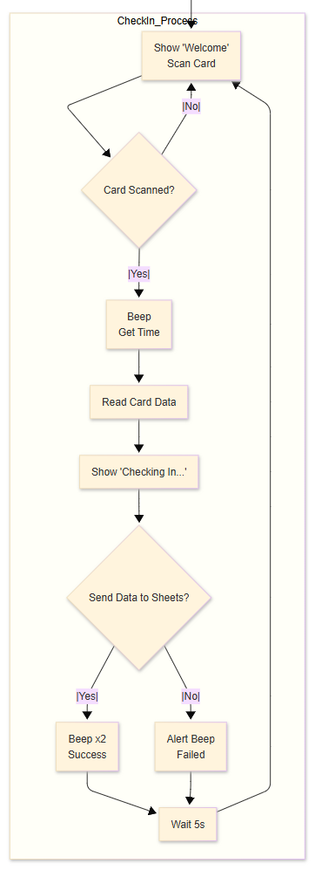

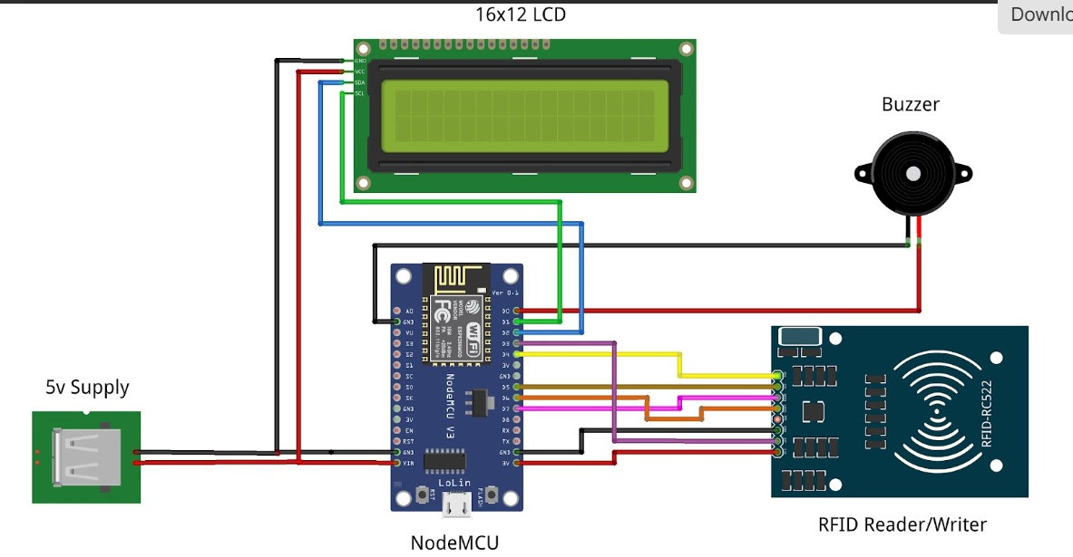
Circuite Diagram

